*HR ANALYTICS Absenteeism Data Analysis*

***Wireframe Documentation***

# Homepage

As per the problem statement, we have divided analysis into three sections: - **1. Impact of absenteeism in day to day operation of a business:**

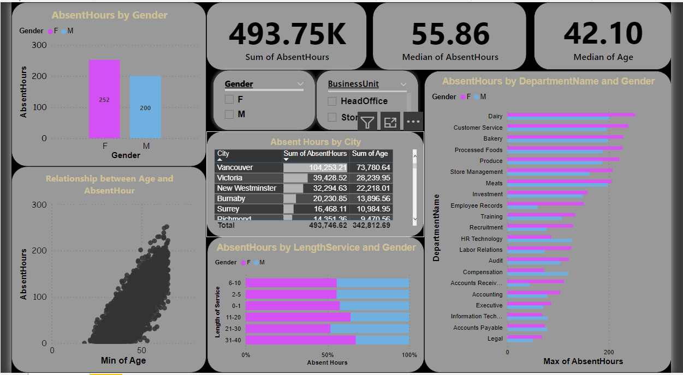

In this section we designed our first dashboard and tried to interpret the followings

* Relation between Age and Absent Hours.

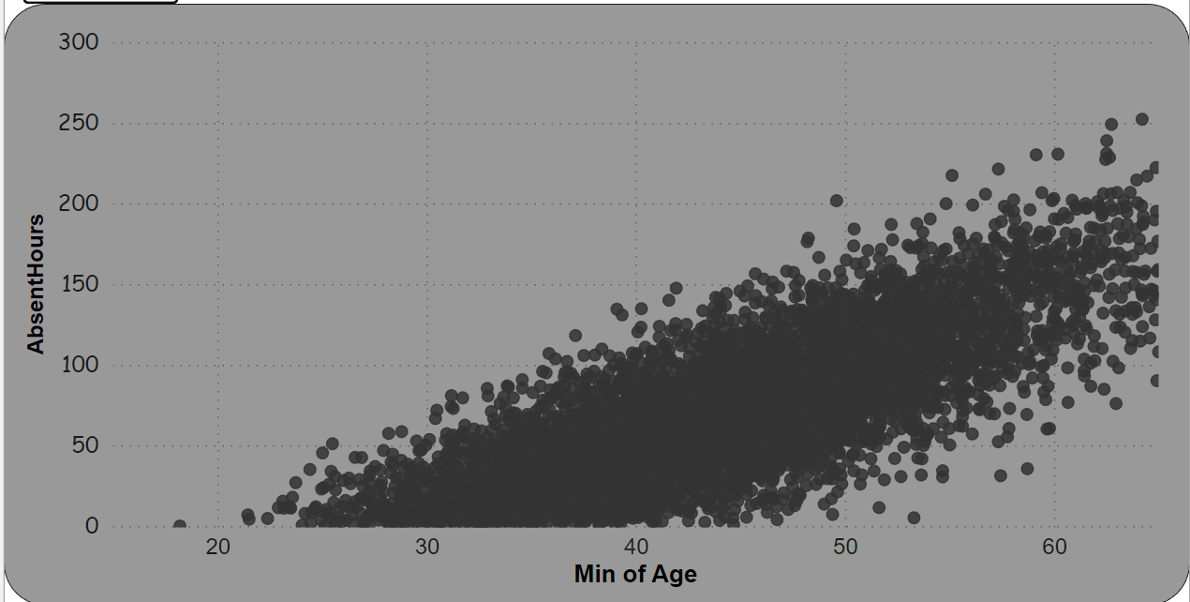

* Absent hours in relationship with Gender.

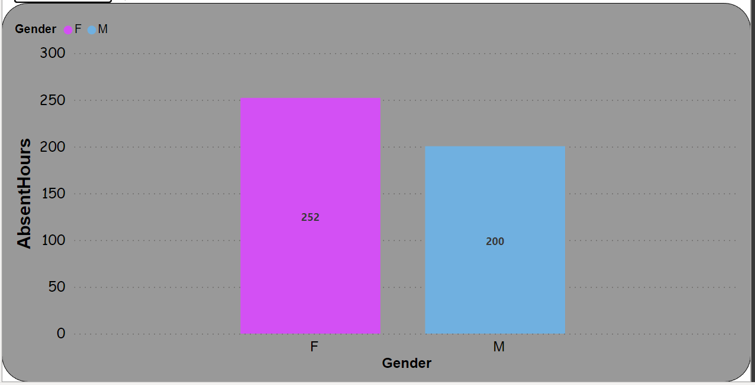

1. **Influence of Absent hours in different cities.**

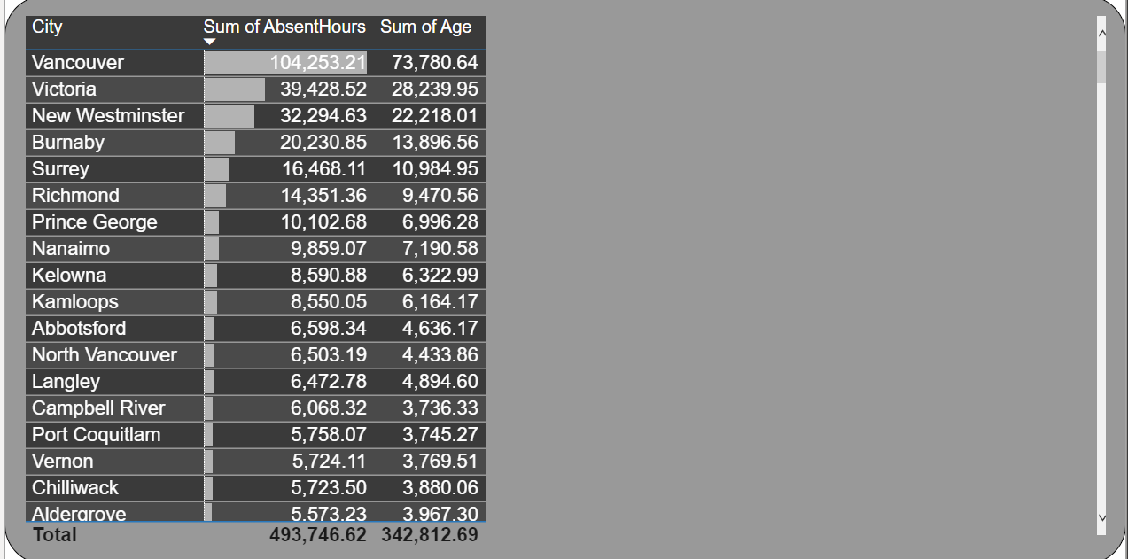

Here, we have our second dashboard and interpret the followings--

* + Distribution of Absent Hours and length of service along with the gender.
  + 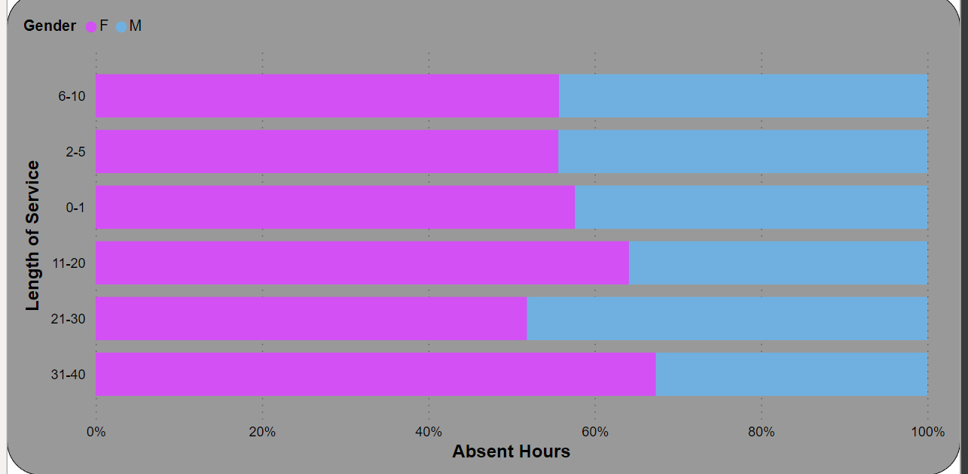

1. **In Dashboard 3, we tried to show Absent hours with respect to different departments along with**

**their Gender.**

